Pythagoras: An Agent-Based Simulation Environment
Pythagoras is an agent-based simulation environment originally developed to support Project Albert, a U.S. Marine Corps–sponsored international initiative that focused on human factors in military combat and non-combat situations. Pythagoras enables a user to create intelligent agents and assign them behaviors based on motivators and detractors. The agents can either act as individuals or be loosely or tightly controlled by one or more leader agents. Pythagoras is written in Java, making it platform-independent. It can be run in a supercomputer environment as a batch job, enabling tens of thousands of repetitions to be run in a short time; can be used and run interactively on a PC through a graphical user interface (GUI), or can be run in batch mode from a PC command prompt.
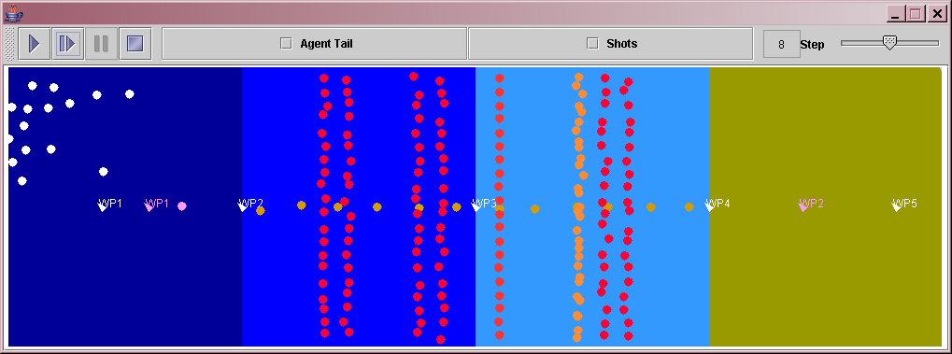
Pythagoras offers the following unique set of capabilities in the area of agent-based simulations:
- Incorporates soft rules to distinguish unique agents
- Uses desires to motivate agents into moving and shooting
- Includes the concept of affiliation (established by sidedness, or color value) to differentiate agents into members of a unit, friendly agents, neutrals, or enemies
- Possesses the concept of influences on behavior through color, attributes or generic resources
- Allows for behavior-changing events and actions (called triggers) that may be invoked in response to simulation activities
- Retains traditional weapons, sensors, communication devices and terrain
A summary of each capability is discussed below.

Soft Rules to Create Individuality
Pythagoras has a feature called soft decision rules, which not only assigns each agent its own threshold within the decision variable trade space but also ensures traceability. Pythagoras allows all decision variables to be softened by the user. The approach is to reflect variation between individual agents by establishing a midpoint for the variable in question and then allowing the user to provide a uniformly distributed range around that value. When an agent is instantiated at the beginning of a scenario run, it selects its decision-variable values from the distribution at random. By controlling the spread, agents can be instantiated as very homogeneous (e.g., well-trained, disciplined military troops) or quite heterogeneous (e.g., a crowd of villagers), or some value in between. Each decision variable has its own control, so some aspects of behavior can be tight, others loose. Figure 1 illustrates three alternative degrees of individuality.
Figure 1: Three alternative degrees of individuality
In each of the three cases illustrated in Figure 1, the midpoint for the behavior variable is 5. That value might, for example, represent the minimum number of enemies from which an agent would retreat. The red uniform distribution represents a firm, homogeneous behavior variable, for which the range is ±1 around the midpoint of 5. The green uniform distribution depicts a softer behavior variable, for which the range is ±2 around the midpoint. The loosest and most heterogeneous of the three definitions for the behavior variable is described by the blue uniform distribution, with a range of ±4 around the midpoint.

Agent Desires to Move
In Pythagoras, agents can be assigned movement desires (listed in the top section of Table 1) to determine their movement paths as a scenario unfolds. During each decision cycle, an agent establishes which desires are active (e.g., too far from a leader), and, if the sum of the desires to move exceeds a user-determined threshold, the agent then uses the strengths of the desires to determine a direction of movement. If multiple desires are active, they can be adjudicated at the user’s discretion by one of four alternative methods:
- Through vector algebra, using direction weighted by desire
- By priority (i.e., the strongest desire)
- At random, weighted by the strength of each desire
- By applying vector algebra for only the two strongest desires
Although the list of existing desires is small, it can be used to represent a variety of behaviors.
Table 1: Decision variables (desires) used to establish agent movement direction and weapon selection
MOVEMENT | Toward (if > d) or Away From (if < d) Closest Leader
MOVEMENT | Toward (if > d) or Away From (if < d) Closest Unit Member/Friendly
MOVEMENT | Toward Furthest Unit Member/Friendly (if > d)
MOVEMENT | Toward Next Way Point (if > d)
MOVEMENT | Toward (if > d) or Away From Nearest Enemy (if < d)
MOVEMENT | Toward Small Number of Enemy (if # Enemy or Ratio Within d < e)
MOVEMENT | Away From Large Number of Enemy (if # Enemy or Ratio Within d > e)
MOVEMENT | Toward Objective
MOVEMENT | Toward Injured Friend
MOVEMENT | Toward Friend (if > d) Needing Fuel, Resource X, Resource Y, Resource Z
MOVEMENT | Toward Friend (if > d) Supplying Fuel, Resource X, Resource Y, Resource Z
MOVEMENT | At Random
MOVEMENT | Continue Same Direction
MOVEMENT | Stay in Place If Desire to Move Is Weak
TERRAIN | Avoid Bad Terrain if (Mobility< or Detect> or Defense< )
TERRAIN | Prefer Good Terrain if (Azimuth, Mobility> and Detection< and Defense
WEAPON | Hold Fire/Free Fire
WEAPON | Highest, Medium or Lowest Lethality Weapon
d – distance e – enemy
Once the agent chooses a direction of movement based on the active desires, the agent reviews the terrain suitability of the selected path. If the terrain is unsuitable because of movement, concealment, and/or protection considerations, the agent first looks to the right and left of the desired path until suitable terrain is identified.

Dynamic Sidedness for Three-Dimensional Affiliation
In Pythagoras, each agent may be assigned a value for each of the three color properties—red, green, and blue—that can be used to establish affiliation among the agents. One, two, or all three of the color properties can be used to establish an affiliation. Different agents can use different sets of properties for their affiliation. Pythagoras uses the terms greenness, blueness, and redness to make the properties generic (and to allow for visual display of the property in the scenario playback tool). Each of the three properties can take a value from 0 to 255 (corresponding to standard color-monitor settings used by Java to control image colors). Figure 2 shows an example of both blue and green being used to establish affiliation.

Figure 2: Two-color sidedness used to establish two-dimensional affiliation
Agents with similar color (as measured by either the difference in absolute value or the root sum square of the differences of the active colors) are considered to be members of the same unit. Those whose color is close are considered to be friends. Those whose color is far away are considered to be enemies. Colors between enemy and friendly agents are neutrals. This approach allows for multiple affiliations within a single scenario, as might be found in a crowd; or it can be used to establish command hierarchies, as would be found in a military organization (e.g., slightly different blue uniforms could represent different companies).
Sidedness, or color value, is governed by soft rules at the start of the simulation (agents can be initiated with more or less redness, for example) and can be changed over the course of the simulation by various events and actions. Because not all colors are required to establish affiliation, colors not used for affiliation could be used to represent a different property—for example, fear, hunger, morale, or intelligence. Increases and decreases in that property can alter agents’ perception of one another. Alternatively, such a change can cause a behavior-change event, as described in the Behavior-Change Triggers section.

Attributes
Similar to Sidedness, Pythagoras has ten agent Attributes. These Attributes act as a supplement to Sidedness and they can affect an agent’s affiliation/sidedness. The meaning of each Attribute is up to the user to define, based upon the user’s scenario. They could be used to represent intangible items such as fear, hunger, and morale or something more concrete such as health or wealth. Attributes can also be selected as in possession of the agent, or not. The Attributes are also governed by soft rules at the start of the simulation (agents can be initiated with more or less Attribute1, for example) and can be changed over the course of the simulation by various events and actions. A change in the value of an Attribute can also cause a behavior-change event.

Resources
Additionally, Pythagoras models logistics capabilities, in the form of fuel and three generic resources (X, Y, and Z). The generic resources allow a user to model any type of resource that would be required for their scenario – for example, food, batteries, and medicine. Fuel may be required for agent movement. These resources are also governed by soft rules and can be changed over the course of the simulation by various events. Additionally, these resources can cause behavior-change events.

Behavior-Change Triggers
Another feature of Pythagoras is the behavior-change event/action, or trigger. When an agent experiences one of the trigger events/actions, the current behavior template may either switch to a new behavior template or experience a side/attribute change. This new template is defined by one or more of the following: new movement and shooting desires, new color-change and attribute values, new resources, weapons, sensors, and/or communication devices, and a new set of behavior-change triggers. For example, an agent can be set to walk up and down a street, as if on patrol, but when the agent is shot at, his behavior changes to look for protective terrain, such as a doorway. The trigger events are (where ‘v’ is determined by the user):
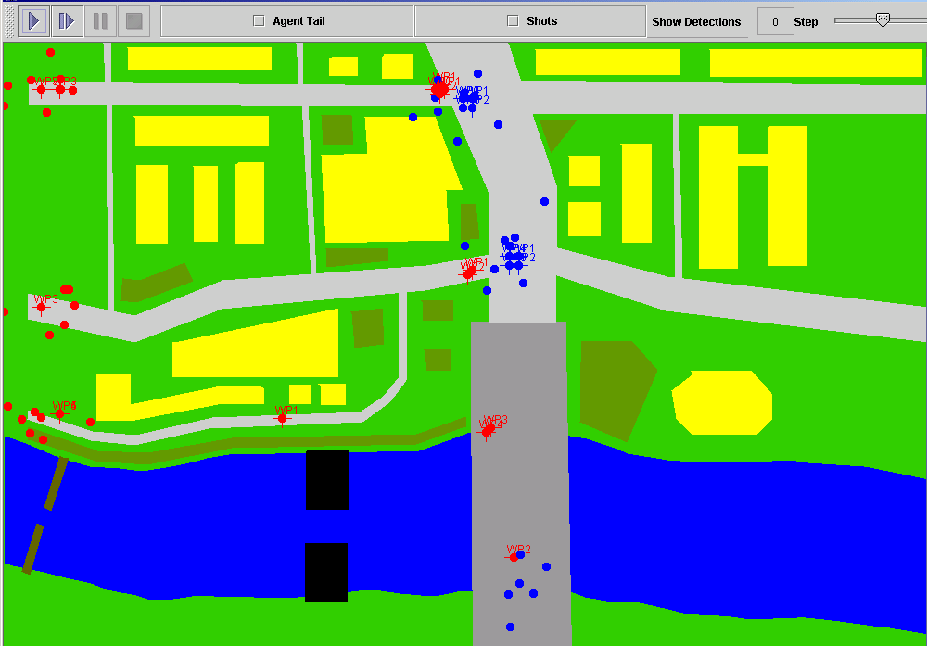
  - Being shot at
  - Detecting an enemy (or friend)
  - Outnumbered/outnumbering the enemy (ratio)
  - Too few friends/Too many enemies (count)
  - Arriving at a way point or objective
  - Friendly casualties (fewer than v% known remaining)
  - Loss of leader (no leader within v distance)
  - Time step (absolute and relative)
  - Red, green, or blue become greater or less than v.
  - An Attribute becomes greater or less than v.
  - Red, green, or blue increase/decrease more than v
  - An Attribute increase/decrease more than v
  - Fuel, resource X, resource Y, or resource Z becomes greater or less than v%.
  - Total ammunition falling below v
  - All is well
Since the behavior template for an agent includes new triggers, and each template is uniquely named, a series of templates can be constructed to represent a complex behavior tree or network, with agents moving from one behavior to another as a scenario unfolds. Also, since agents are separate objects, different agent types can share the behavior templates. Additionally, there is no practical limit to the number of templates that can be created.

Weapon Options
Pythagoras allows agents to carry as many as ten different weapons. Weapons can be either direct-fire (which requires a line of sight) or indirect- fire (which does not):
- Direct-fire weapons have range-dependent probabilities of hit, and of kill given a hit (these factors may be affected by the target agent’s vulnerability).
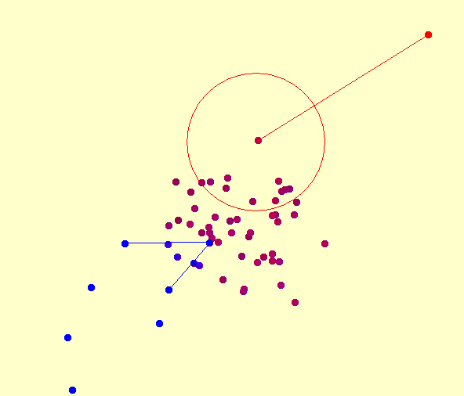
- Indirect-fire weapons have circular-error-probable accuracies and lethal radii, both of which may be range-dependant.
An indirect-fire weapon’s lethal radii can be modeled using either the traditional Carlton damage function or a “cookie-cutter” blast. The Carlton damage function describes the probability of damage incurred radiating out from a hit point. The cookie-cutter blast causes an equal amount of damage to all objects within the blast radius, regardless of their distance from the impact point. Both weapon types have input rates of fire and limited ammunition.
In Pythagoras, the target may be suppressed for multiple time steps by a hit by a direct-fire weapon or a near miss by an indirect-fire weapon that does not kill the target. Suppressed agents do not move, sense, communicate or shoot, but they recover those capabilities after a user-input amount of time. At the user’s discretion, kills can be random (stochastic), deterministic (fractional damage), or a combination of both.
Agents will automatically shoot at enemies within range, unless they are given a “hold fire” command. The user can assign an agent multiple weapons and set the weapon selection criteria to be based on the highest probability of hit (best chance that the target will be suppressed), the lowest probability of kill (for a non-lethal situation), or a medium probability of hit.
Agents can also change each other’s colors or attributes, through the use of military countermeasures or weapons that can act as paintball weapon. An example of a paintball weapon would be propaganda that alters an agent’s affiliation in some way. Propaganda in the form of leaflets can be modeled as a direct-fire weapon aimed at a specific target. On the other hand, a form of public speech or exhortation can be modeled as an indirect-fire weapon, aimed in a general direction and affecting everyone within range.

Multi-Band Sensors and Communication Devices
Pythagoras also models sensors and communication devices. Each agent may have up to ten sensors, each of which operates in a specific signature band (labeled A, B, or C). The sensors have a range-dependent probability of detection, which is modified by intervening terrain and the target agent’s detectability factor. For example, signature band A could represent the bandwidth of the naked eye and signature band B might represent the bandwidth of an infrared device. A terrain feature, such as foliage, would thwart the naked eye’s view, but an infrared device could “see” the thermal image of a camouflaged person standing in the foliage. Such foliage could be modeled in Pythagoras as having a concealment value of 100% in band A and 0% in band B. Sensors also have a field of view and, for modeling humans, a probability that the agent is looking forward (i.e., in the direction of travel), to the side, or to the rear.
Similarly, an agent can possess up to ten communication devices, each of which operates either via line-of-sight or in a broadcast mode, and allows the agent to use the devices to talk, listen or both. Each communication device also operates via a specific channel or channels (up to three allowed). Each communication device’s channel can pass along an Attribute Changer that can change the attributes of agents receiving messages on that channel.

Representation of Terrain
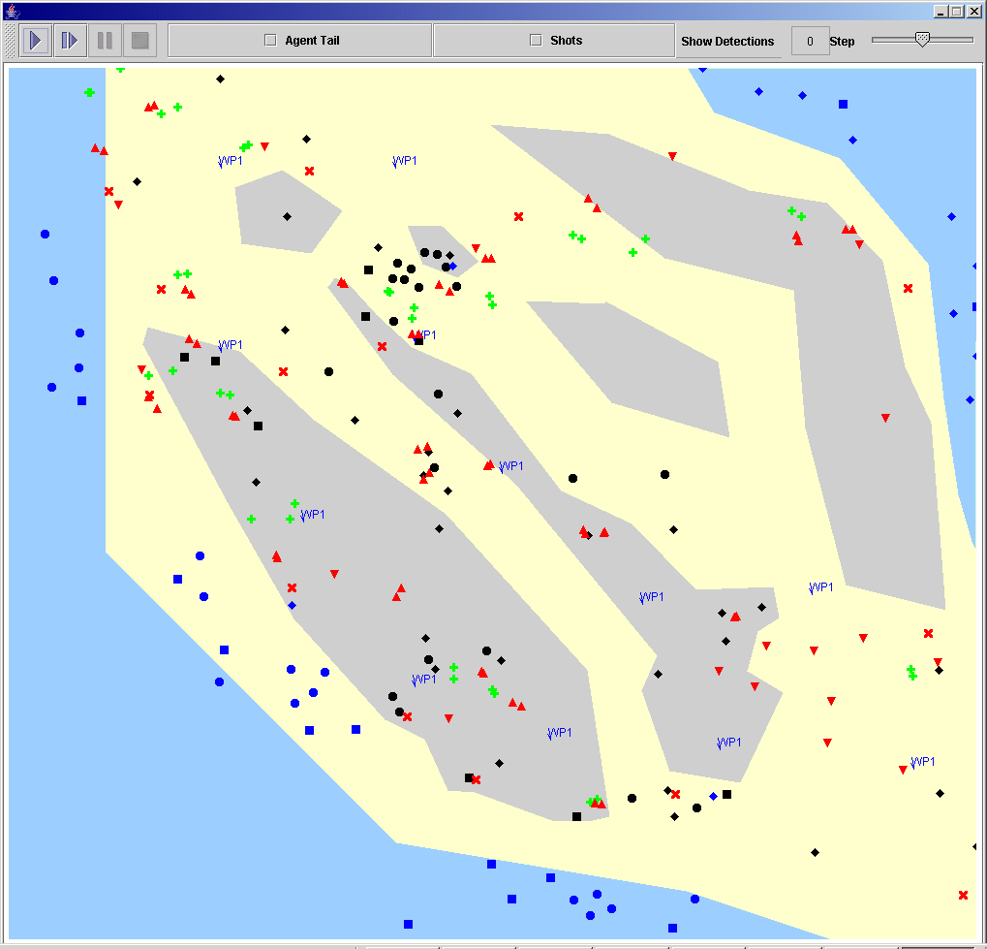
All agents exist in a user-defined playbox of up to 4000 × 4000 pixels. In the playbox, a user can create terrain features—polygons that have a floor, a ceiling, and factors for mobility; concealment in each of the three signature bands; and protection that reduces the weapon’s effectiveness. Currently, a pixel can be associated with at most one terrain feature. Agents can either move on the terrain or floor or operate at an altitude above the terrain. Terrain features can also have an Attribute Changer associated with them, which means that any agent located on the terrain feature (during the time the attribute changer is active) may be affected by the attribute changer.

Sample Scenarios
Pythagoras has two major advantages:
- It can be used quickly to assess various simple scenarios.
- It can be combined with more complex and detailed models to provide insights into situations that may not be possible with other simulations.
Rapid prototyping of scenarios, weapons, sensors, behavior patterns, etc., allows users to undertake complex problems in new ways without the burden of months of software (and scenario) development. Table 2 provides a representative list of scenarios that have been developed within Pythagoras.

Table 2: Representative Pythagoras Scenarios
Historical Analysis (USNA): | - Battle of Midway
Historical Analysis (USNA): | - Operation Market-Garden
Historical Analysis (USNA): | - Battle of Ia Drang, Viet Nam
Thesis Topics (NPS): | - Sea-Based Logistics
Thesis Topics (NPS): | - Convoy Protection
Thesis Topics (NPS): | - Unmanned Surface Vehicles
Thesis Topics (NPS): | - Future Force Warrior Small Combat Unit With Non-Lethal Weapons
Thesis Topics (NPS): | - Emergency First Response To A Crisis Event
Thesis Topics (NPS): | - Effectiveness of Non-Lethal Capabilities in a Maritime Environment
Thesis Topics (NPS): | - Exploration of Force Transitions in Stability Operations Using Multi-Agent Simulation
Cadet Capstone Project (USMA, West Point) | - Sensor Placement on the Battlefield
Study on Actions Off of Bay of Biscay (AFIT) | - Anti-Submarine Warfare
Thermobaric Weapons Assessment (MCCDC) | - Urban Environment
MAGTF Optical Requirements (Night Vision Lab/Ft. Belvoir) | - Peacekeeping at Night in Urban Environment
Shallow Water Obstacle Clearing (MCWL) | - Use of JDAM and Robotics
Environmental Concerns (MITRE) | - Spread of Hemlock Wooly Adelghid
Homeland Defense (Northrop Grumman) | - Pre-proposal Analysis
Terrorist Development (Sandia Labs with Marc Sageman of University of Pennsylvania) | - Conceptual Model of Human Factors
Soldier Technology Development (Northrop Grumman) | - Less Than Lethal Technologies for Urban Combat
Securing Targets of Interest (JCS/J-8, DMSO) | - Competition Between Multiple Factions
Marine Expeditionary Rifle Squad (MERS) (USMC/OAD) | - Trade-offs Between Different Equipment

Source for Acquiring Pythagoras
Pythagoras can be acquired from the Simulation Experiments & Efficient Designs (SEED) Center for Data Farming located at the Naval Post Graduate School (NPS):

http://harvest.nps.edu/

The Northrop Grumman developers listed below can be contacted for further requests for information or questions about Pythagoras:

Donna Middleton: donna.middleton@ngc.com
Brittlea Sheldon: brittlea.sheldon@ngc.com
Edmund Bitinas: edmund.bitinas@ngc.com
Pete Bulanow: pete.bulanow@ngc.com

